**CHENDHURAN COLLEGE OF**

**ENGINEERING AND TECHNOLOGY**

ACCREDITED BY NAAC WITH 'B++ ' GRADE

Lena Villakku,Pilivalam Post ,Thirumayam Taluk,Pudukkottai.

Phone : 73737 55574 Website: [www.chendhuran.ac.in](http://www.chendhuran.ac.in)

**PROJECT REPORT**

**TITILE : GOLDEN BOND SCHEME**

**SUBMITTED BY,**

**TEAM LEADER :** HEMA R

**TEAM MEMBERS :** ABDUL KAREEM GADHAFI A,

SANTHOSH M,

KASTHURI S

**DEPARTMENT OF**

**COMPUTER SCIENCE AND ENGINEERING**

**TABLE OF CONTENTS**

**CHAPTER NO. TITILE**

1. **INTRODUCTION**

1.1 Overview

1.2 Purpose

**2. Problem Definition &**

**Design Thinking**

2.1 Empathy Map

2.2 Ideation & Brainstorming Map

**3. RESULT**

**4. ADVANTAGES & DISADVANTAGES**

**5. APPLICATIONS**

**6. CONCLUSION**

**7. FUTURE SCOPE**

**1. INTRODUCTION**

The "Golden Bond Scheme" is not a widely recognized or commonly used term in the financial or investment world as of my last knowledge update in January 2022. Therefore, I cannot provide specific information about this scheme.

It's possible that this term may refer to a financial or investment program or initiative that was introduced or became relevant after my last update. If that's the case, I would recommend checking with credible financial news sources, government announcements, or relevant financial institutions for the most up-to-date information and details regarding the intention and objectives of the "Golden Bond Scheme."

Financial and investment schemes often have specific goals, such as raising capital for government projects, promoting investment in certain sectors, or providing attractive investment opportunities for individuals. To understand the intention of a specific scheme, you would need to refer to official documents and statements related to that scheme.

**1.1 Overview**

"Golden bond scheme" often refers to the government or state, so a " Golden bond scheme " might potentially involve a government-backed or authorized financial initiative. Such a scheme could be related to gold-based investments, savings, or a financial instrument supported by a government.

This scheme contains the some offer that monthly investor get high interest of amount and we are provide that you will take load from this bond at after the 5 years completed. If you're looking for information on a " Golden Bond Scheme" or a similar program, I recommend checking with credible financial news sources, government authorities, or financial institutions for the most up-to-date and accurate information about this scheme. We can provide you with details on its objectives, terms, and how it works.

**1.2 Purpose**

The specific purpose of a bond scheme can vary widely depending on the issuer's needs and objectives. Bond schemes may also be designed to meet particular financial goals, whether it's raising funds for a specific project, refinancing existing debt, or providing an investment opportunity to the public.

**Debt Financing**: Bond schemes allow issuers to obtain long-term debt financing. Bonds typically have fixed maturity dates, and issuers repay the bondholders when the bonds mature. This provides a structured and predictable way to manage debt.

**Diversification for Investors:** For investors, bond schemes offer an opportunity to diversify their investment portfolios. Bonds provide a more conservative and stable investment option compared to equities, which can be more volatile.

**Income Generation**: Bonds pay periodic interest (coupon payments) to bondholders. These payments provide a source of income for investors, making bond schemes attractive for income-oriented investors, such as retirees.

**Risk Management:** Bonds can be used for risk management. For example, issuers may use convertible bonds to raise capital while giving bondholders the option to convert their bonds into common stock. This can be a way to manage dilution.

**Infrastructure and Project Financing:** Governments often issue bonds to finance infrastructure projects, such as building roads, bridges, and public facilities. This allows them to spread the cost of large projects over time.

**Economic Stabilization:** In some cases, governments may issue bonds to influence monetary policy and manage the money supply. For example, they might issue or buy back bonds to control interest rates.

**Providing Investment Alternatives:** Bond schemes provide investors with an alternative to traditional savings accounts or fixed deposits, potentially offering higher yields.

**2 . Problem Definition & Design Thinking**

It seems like you are looking for a problem definition related to a "Gold bond Scheme." However, the term "Gold Bond Scheme" is quite broad and could encompass various initiatives or programs related to gold, such as gold investment schemes, gold savings plans, or gold-related government programs. To provide a problem definition, it's essential to have more specific information about the context or the particular gold scheme in question.

Designing thinking of our project is to make one advertising video to make marketing of our scheme.we had one brand video to market the golden bond scheme.we had done brainstrom design and empathy design to completely describe about our project.

**2.1 Empathy Map**

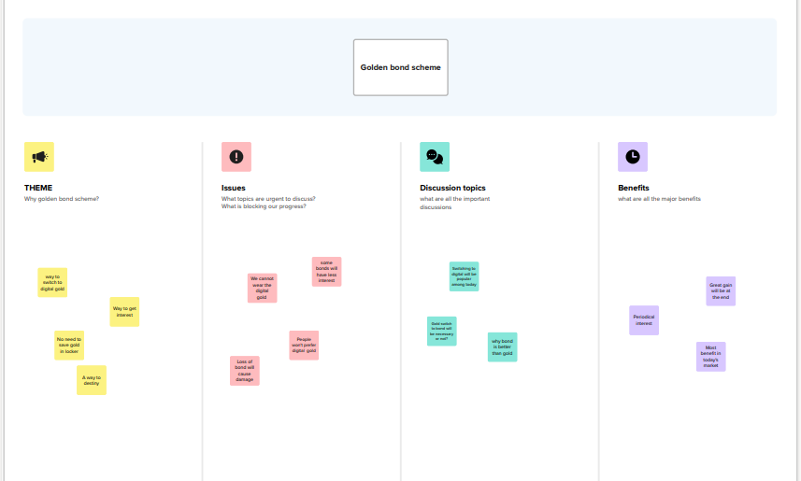

**2.2 Ideation & Brainstorming Map**

The "Golden Bond Scheme" can be conceptualized in various ways depending on the goals and objectives you want to achieve. Below is an ideation of a fictional "Golden Bond Scheme" that combines the allure of gold with an investment program:

**Name:** Golden Bond Scheme

**Objective:** To encourage long-term savings and investments while capitalizing on the appeal of gold.

**Key Features:**

**Gold-Backed Bonds:** The scheme offers bonds backed by physical gold reserves held by the government or a trusted financial institution. Each bond represents a certain amount of gold.

**Interest Payments:** Bondholders receive regular interest payments, which can be in the form of additional gold or currency, making it attractive to gold enthusiasts and investors.

**Maturity Options:** Investors can choose from different maturity options, such as short-term, medium-term, and long-term bonds. Longer-term bonds offer higher returns.

**Flexible Redemption:** Bondholders have the flexibility to redeem their bonds for physical gold at any time or receive cash equivalent to the current market value of the gold.

**Tax Benefits:** Offer tax incentives to investors who hold their bonds for a certain period, encouraging long-term investments.

**Safety and Transparency:** Ensure that the gold reserves backing the bonds are held securely and transparently, with regular audits and reports.

**Accessibility:** Make the scheme accessible to a wide range of investors, with low minimum investment thresholds.

**Marketing and Education:** Promote the scheme through educational campaigns highlighting the value and stability of gold as an investment.

**Government Partnership:** Collaborate with the government to issue and regulate these bonds, ensuring investor trust and confidence.

**Social and Environmental Responsibility:** A portion of the returns could be invested in eco-friendly and community projects, aligning the scheme with responsible investment principles.

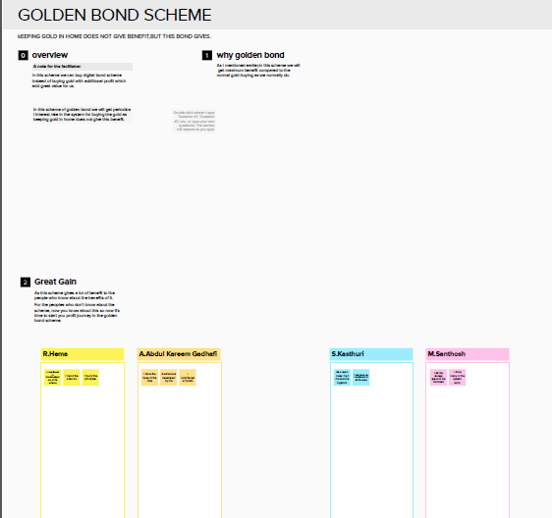

**3.RESULT**

<https://www.canva.com/design/DAFxVJTNjvI/XyhMD6cdsDxlVY5S39mmkA/edit>

**4.APPLICATIONS**

We had upload this marketing video on youtube . We can share this video to make possible markting with other then to we can complete digital marketing successfully.

**5.CONCLUSION**

"Golden Bond Scheme" may have been introduced or gained relevance after that date, or it may be a unique or localized program with limited public information.

If you are seeking information or a conclusion about a particular "Golden Bond Scheme," I recommend consulting official government sources, financial institutions, or relevant authorities for the most accurate and up-to-date details about the scheme, its objectives, and its impact.

**6.FUTURE SCOPE**

**Market Demand:** The scheme's success and future scope would be influenced by the demand for gold-related investments and the willingness of investors to participate.

**Economic Conditions:** Economic factors, such as interest rates, inflation, and overall financial stability, can impact the attractiveness of bonds and gold as an investment.

**Government Policies:** Government support and regulations can play a significant role in shaping the future of such a scheme, including tax incentives, issuance terms, and security measures.

**Investor Confidence:** The level of trust and confidence investors have in the scheme, including the transparency of gold reserves and the issuer's credibility, will be critical.

**Global and Local Trends:** Global and local economic and market trends, as well as changes in the price of gold, will affect the scheme's future prospects.

**Marketing and Education:** Effective marketing and educational efforts can increase awareness and participation in the scheme, potentially expanding its scope.

**Flexibility and Innovation:** The ability to adapt to changing market conditions and investor preferences can enhance the scheme's future viability.

The future scope of a "Golden Bond Scheme" would depend on its ability to meet the evolving needs and expectations of investors while providing a secure and attractive investment opportunity. To make informed predictions about its future, it's essential to have up-to-date information and monitor how the scheme is received in the market.